**VD-67S**

**UHF RFID Desktop Reader**

**Software operation manual**

Contents

1 Software operation 3

1.1 SET UP TESTING SYSTEM 3

1.2 START UP THE TESTING SOFTWARE 3

1.2.1 Type-c CONNECTION 4

1.3 SET READER PARAMERTER 6

2 WRITE TYPE ISO18000-6C TAGS 10

2.1 THE PROGRAM OF READING AND WRITTING 10

2.2 generate data to write 10

2.3 writeting operation of tags 12

2.3.1 IMPORT DATA 12

2.3.2 WRITE TAGS 14

2.3.3 COMPLETE DATA LIST 15

3 READ TYPE ISO18000-6C TAGS 16

3.1 PROGRAM INTERFACE 16

3.2 READING STEPS OF ISO18000-6C TAGS 17

3.2.1 SELECT:FIRST CHOOSE THE DATA SECTION TO READ。 17

3.2.2 SELCT READING INTERVAL 17

3.2.3 READ DATA OF TAGS 17

4 WRITE TYPE ISO18000-6B TAGS 20

4.1 THE PROGRAM OF READING AND WRITTING 20

4.2 generate data to write 20

4.3 writeting operation of tags 22

4.3.1 IMPORT DATA 22

4.3.2 WRITE TAGS 23

4.3.3 COMPLETE DATA LIST 24

5 READ TYPEISO18000-6b TAGS 25

5.1 PROGRAM INTERFACE 25

5.2 SELCT READING INTERVAL 25

5.3 READ DATA OF TAGS 25

# Software operation

## Set up testing system

Illustrated as below :

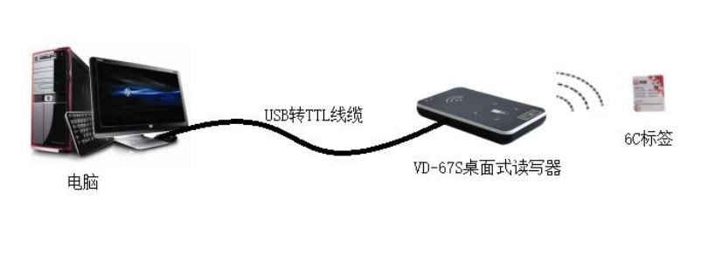

Image 1 VD-67S desktop reader connection sketch

1. Connect the reader to PC through the Type-c port.
2. Run the Demo software for VD-67S desktop reader on PC, set reader index and test reading, writing for the reader according to the notes below.

## Start up the testing software

The CD-ROM for VD – 67S contains『Demo Software』Demo.exe, this program needs to be run in Microsoft Windows XP, Windows 7or Windows 8 Operating system. Clicking VD-67S Write Card.exeicon to start up the testing software.

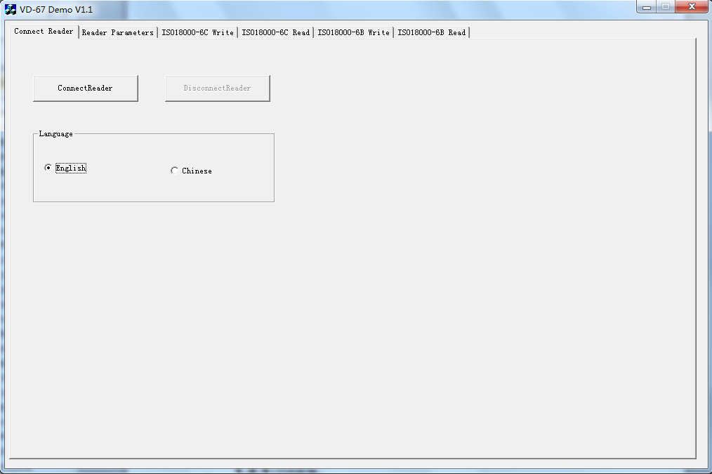

Image 2 interface of connecting VD-67Sdesktop reader shown in Demo

### Type-c connection

PC can exchange data with reader through a Type-c port. For the first time to use, User need to initialize VD-67S by Type-c port for taking network communication.

1. Switch work mode: Press work mode changing button for 3s, when reader rings ”di”, it means VD-67S has been changed to HID-compliant Device mode. Then you can use VD-67S Demo to connect the reader.

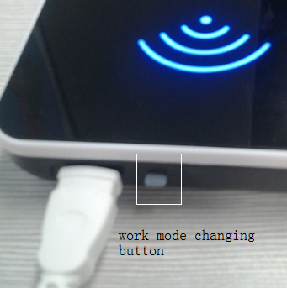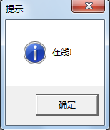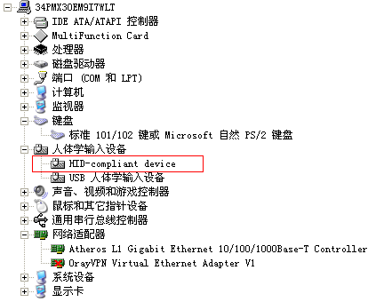

1. Click『ConnectReader』icon，

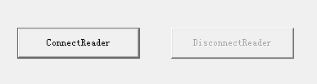

If successfully connected, you will see the following clew box popped up.

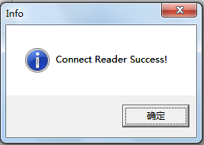

If reader connected to PC failed or the selected serial port is wrong, you will see the following clew box popped up.

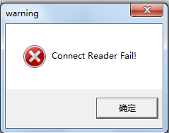

## Set reader’s parameter

The following image is the operation page for setting parameter for VD-67S.『Reader Parameters』:

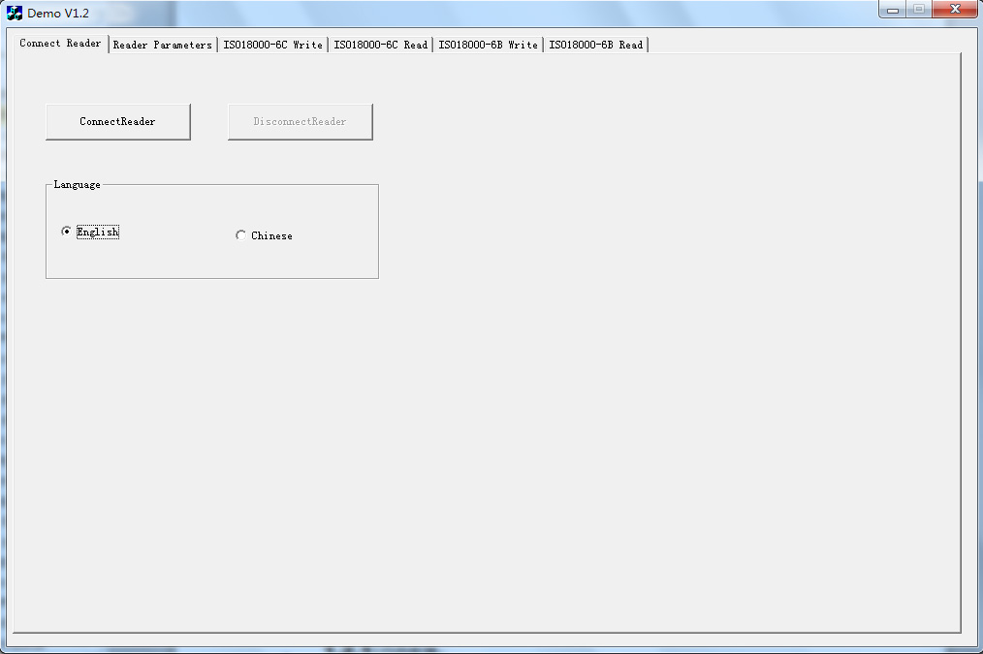

1. Select Operation Mode

There are 2 operation modes for VD-67S as below:

* HID-compliant Device mode: readers begin to work after receive legal control command through Type-c, and return the command results through that port.
* HID Keyboard Device mode: reader reading tags automatically by sending out signals at regular intervals, and output the reading results in the set data format through Type-c port when successfully read. No output if read failed.

1. Basic Parameters

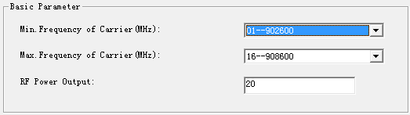

No matter in which operation mode, The user need to set 2 parameters as below:

* RF Power Output: Set output power for the reader. Usually this parameter has been set to the optimal before EX- factory, i.e. the reading range is the longest and performance is the best. If no special requirements, please don’t modify this parameter.
* Operation frequency:

Min. Frequency of Carrier: set the min operation frequency for the reader Max. Frequency of Carrier: set the max operation frequency for the reader.

For different countries or regions, there are corresponding choices in the listed working frequency based on local radio rules requirement. Users can choose sensitive frequencies according to local conditions. If choose a Fixed Frequency point, set the Min. Frequency of Carrier the same as to Max. Frequency of Carrier; If use frequency hopping, please choose fmin as the Min. Frequency of Carrier, fmax as Max.Frequency of Carrier, as long as fmax>fmin. As below:

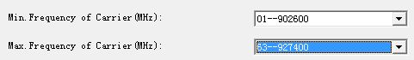

1. Operation Parameter of HID Keyboard Device mode

* Tag types to be read: VD-67S desktop reader can read ISO18000-6C and ISO18000-6B tags.
* Data format: Optional for hex or decimal output.
* Choose data area

| Tag type | Data area | Data length（bit） |
| --- | --- | --- |
| ISO18000-6C | EPC | 96 |
| TID | 64 |
| USER | 512 |
| ISO18000-6B | ID |  |
| USER | 220～223 |

* Prefix and Prefix value



choose; for example, prefix are 1234, you will read tags start with 1234 under HID Keyboard Device mode.



For enter and wrap, select , the output tag numbers will be auto line fed.



* Data address:



The connection among initial address, types of tags and length of output number. Set length of output number as 3.

| Start Bit ADD on output card ID | EPC C1G2 (112233445566778899001122) | ISO18000-6B (E0044BDF23010000) |
| --- | --- | --- |
| 0 | 223344 | 044BDF |
| 1 | 334455 | 4BDF23 |
| 2 | 445566 | DF2301 |
| 3 | 556677 | 230100 |
| 4 | 667788 | 010000 |
| 5 | 778899 | Un-use |
| 6 | 889900 | Un-use |
| 7 | 990011 | Un-use |
| 8 | 001122 | Un-use |

* Interval of Reading: it means how long suspend after read tag , optional for 5 choices: 10ms，20ms，30ms，50ms，100ms. Usually when read tags on slowly moved objects, time intervals is long. Otherwise, time intervals is short.
* Standard output interval（1~255）:When read the same number in a long time, according to the set number in『output interval, it will output just 1 time, if not the same number, then output immediately.

# Write ISO18000-6C tags

## The program of reading and writing

When using VD-67S Type-c desktop reader to write tag ISO ISO18000-6C, please do it as following way:

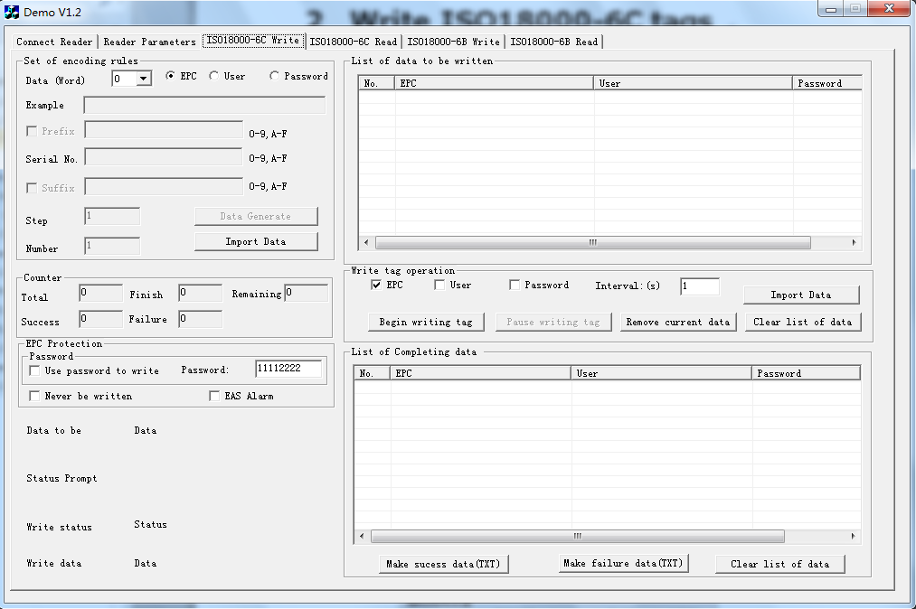

## How to list the wanted tag ID

**Set encoding rules:**

Data bits（word）: Length of data bits is 0~8word，users can set the word according to length of data bits.

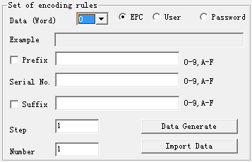

Data area：Optional for EPC, user area, password area.

| Data area | Data length（word） |
| --- | --- |
| EPC | 6 |
| TID | 4 |
| USER | 4 |

Prefix（hexadecimal）: Prefix of the tag ID which to being write, use word as the unit.

Initial sequence number（hexadecimal）: Initial sequence number of the tag ID Which to being write, use word as the unit.

Suffix（hexadecimal）：Suffix the tag ID which to being write use word as the unit.

The cumulative step: The number added up every time.

Number of generated: how many tags asked to write.

**Input the generating rule of data:**

Refer to the following picture to set encoding rules, click the『 according to rules to output data』, you will see the generated data in the 『the data to write list』at the right side.

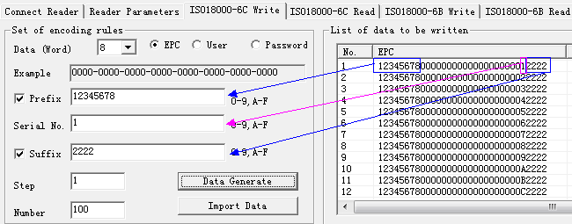

## Writing tags

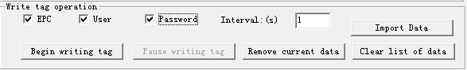

### Import data

Select the data area you want to write.



Click import data, you will see popup of the following window.

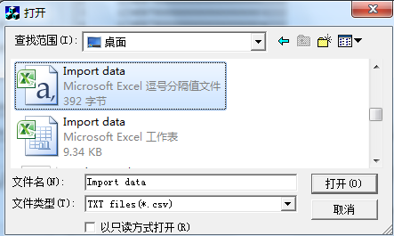

Select the data to input, click to open it. Then the data is input to the list of data to write.

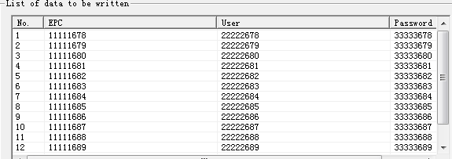

Statement:

1.If the data area to input is EPC area, user area, password area, then the data format of csv. should be as following:

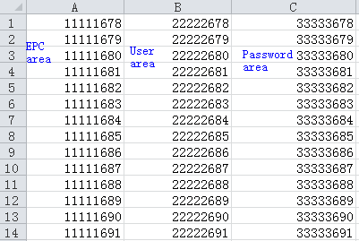

2.If only input user area and password area, then data format of csv should be as following:

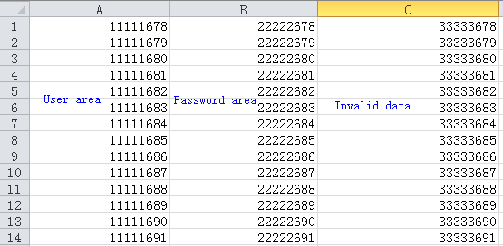

EPC protection: there are two choices.

**Use password to write:** only can be written when knows the password; later can be set as permanently locked or free to write or permanently written.

**Never be written:** Even if knows the password, still can not write, i.e. can not write permanently.

**Password**：Visiting password（32bits）

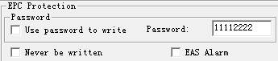

Remove current data：select the data to be deleted in the data list, then click remove current data. The selected data will be moved to list of completing data.

Clear list of data: clear the list of data to be written.

### Write card

Click starting to write cards, put the card on VD-67S

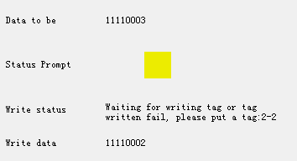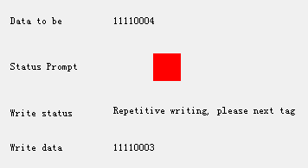

### List of completing data

List of completing data: the data has successfully write in cards and the data deleted will be shown in this data list.

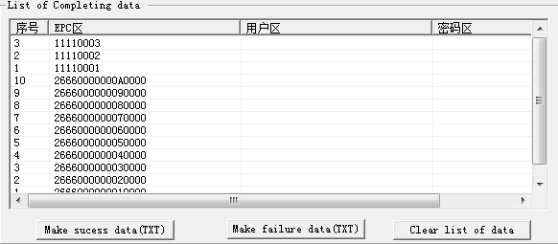

# . Reading tag ISO18000-6C

## Interface of program

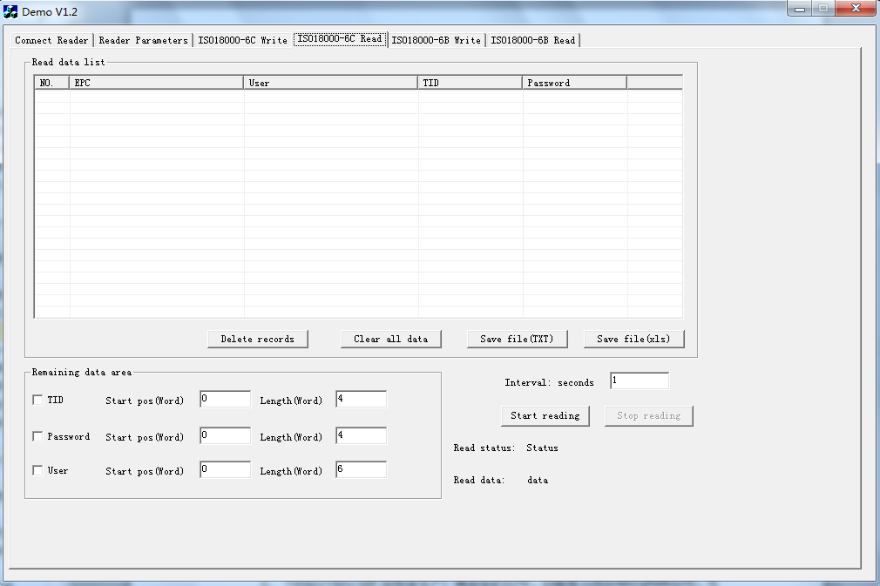

1. ISO18000-6C tags storage unit

Divide into for areas:

* 1. EPC area(EPC):the area to store EPC number, currently can store maximal 96bits of EPC number. Readable and writable.
  2. TID area(TID):the area to store the ID number set by tag manufacturer, currently have 32 and 64 bits those two kinds of ID number. Readable but un-writable.
  3. User area(User): Vary from different manufacturers. Impinj’ s G2 tags don’t have user area. NXP’s tags have 224 bits. Readable and writable.
  4. Password area: there are 32bits visiting password and 32bits killing password. Readable and writable.

Four storage areas all can be write with protection. Writing with protection means this area permanently un-writable or un-writable under unsafe condition. Reading with protection means only password unreadable.

## Reading steps for tag ISO1800-6C

**Divided into three steps:**

### 3.2.1 Select: Firstly, select the data area to read.

The program’s default set is to read EPC area,

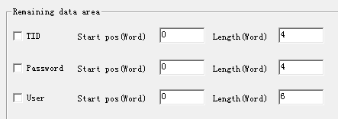

### 3.2.2 Secondly, select the reading interval

Reading interval optional: 0~255s.



### 3.2.3 Thirdly, read the data of tag,

Click start to read

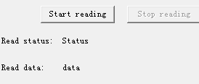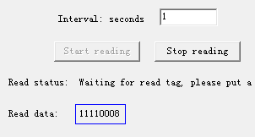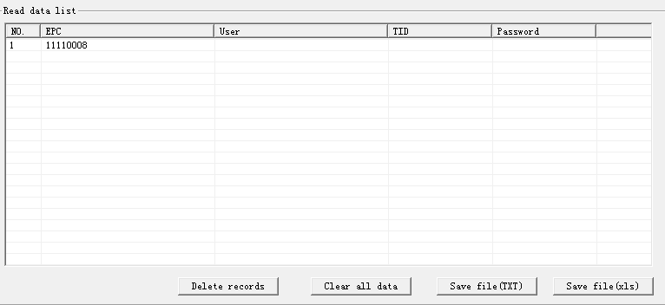

Delete records: Delete the selected data of tags in the read data list.

Clear all data: clear all read data in read data list.

Save file(TXT): click save file(TXT), then data in read data list will be saved as .txt file.

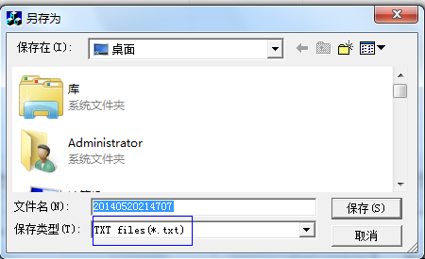

Save file(xls): click Save file(xls), then can save as .csv file.

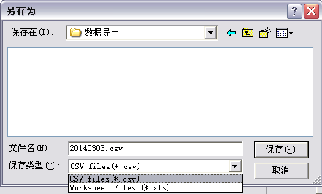

# Write ISO18000-6B tag

## 4.1 The program of reading and writing

When taking VD-67S Type-c desktop reader to write ISO ISO18000-6B tag, please do it as following way:

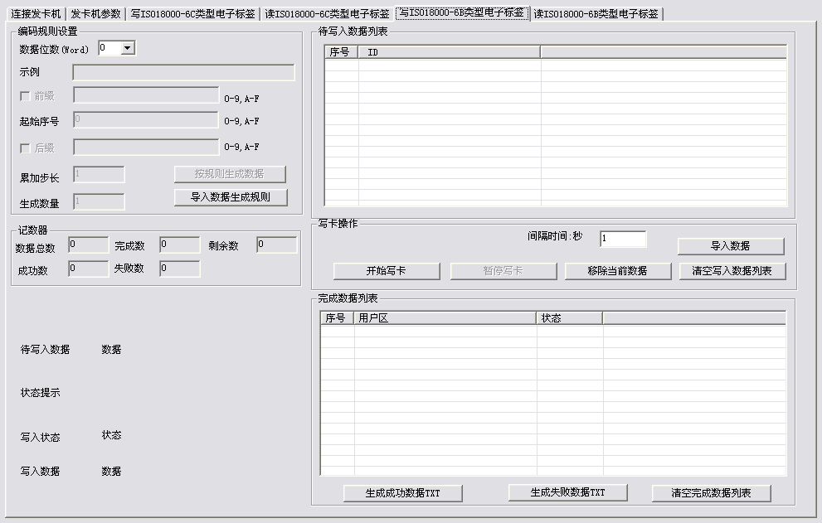

## Generate data to write

**Set encoding rules:**

Data bits（word）: Length of data bits is 0~8word，users can set the word according to length of data bits.

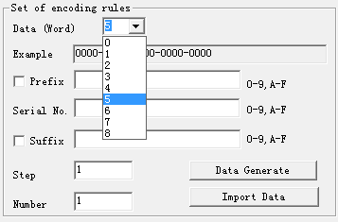

Data area：Tag ISO18000-6B’s user area can be written.

| Data area | Start ADD | Data length （word） |
| --- | --- | --- |
| USER | 8-223 | 1~4 |
|  |  |  |

Prefix（hexadecimal）: Prefix of the data which being to write, use word as the unit.

Initial sequence number（hexadecimal）: Initial sequence number of the data of the data which being to write, use word as the unit.

Suffix（hexadecimal）：Suffix of of the data which being to write, use word as the unit.

The cumulative step: The number added up every time.

Number of generated: How many tags ID going to be read.

**Input the generating rule of data**

Refer to the following picture to set encoding rules, click the『Data Generate』, you will see the generated data in the『List of data to be written』at the right side.

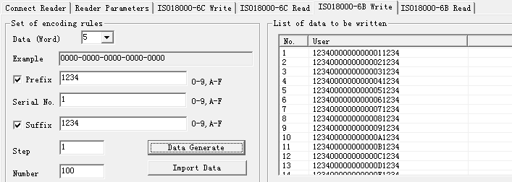

## Writing tags

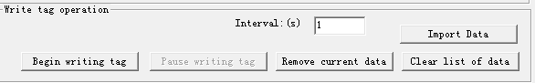

### Data import

Click Import Data, you will see popup of the following window.



Select the data to input, click it. Then the data is input to the list of data to write.

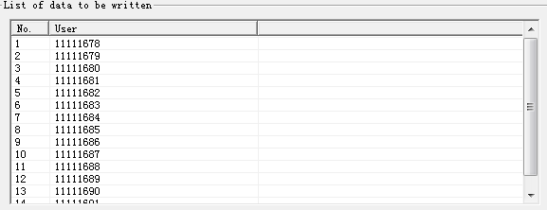

Statement: 1. If import data area is user area then the data format of csv should be as following:

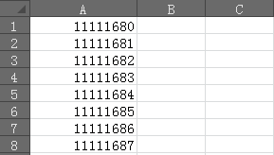

Remove current data：select the list of data to be written, then click Remove current data. The selected data will be moved to list of completing data.

Clear list of data: clear list of data to be written.

### Write card

Click starting to write cards, put the card on VD-67S



### List of completing data

List of completing data: the data has successfully write in cards and the data deleted will be shown in this data list.

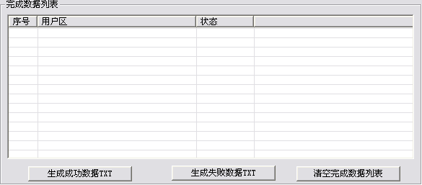

# Read tag ISO18000-6B

## Interface of program

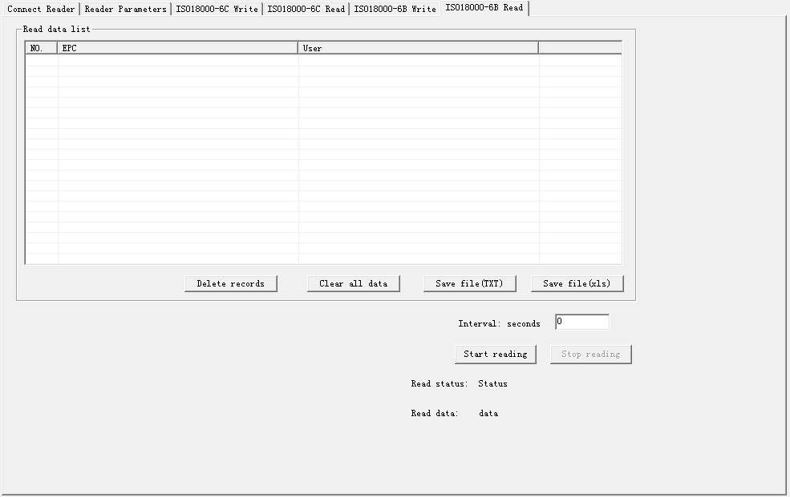

## Select the reading interval

Reading interval optional: 0~255s.



## 5.3 Read the data of tag

Click start reading.



Delete records: Delete the selected data of tags in the read data list.

Clear all data: clear all read data in read data list.

Save file(TXT): click save file(TXT), then data in read data list will be saved as .txt file.



Save file(xls): click Save file(xls), then can save as .csv file.

